Circle Language Spec: Parameters

Required & Optional in a Diagram
Optional is the default behavior. Required is an extra rule imposed. Required is expressed by drawing half a shape at the end of a connector. It should be half of what has to be connected to it. Most of the times it will be half a circle:

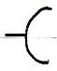

For command objects it is half a square:

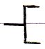

And when a command needs to be executed it is about 5/8th of a diamond:

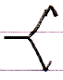

It is not half a diamond because that already symbolizes the Protected access modifier, which is half a cross:

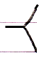

For system commands that require the command call connector notation, also the 5/8th of a diamond is shown when a call is required:

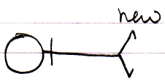

The ‘half a shape’ will also get a line type adapted to the role the required object will get. If the connector specifies that it gets a class role, the half-shape will be drawn with a dashed line.

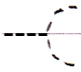

Below you will find examples of required connectors. Not every possible connector is shown, but enough to cover the notation.

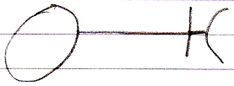 | 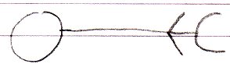 | 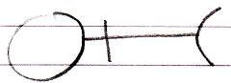
Public Required  Object Set | Protected Required  Object Set | Public Required  Object Get
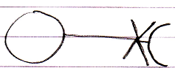 | 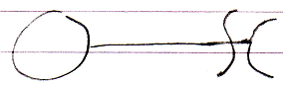 | 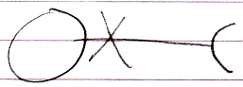
Private Required  Object Set | Friend Required  Object Set | Private Required  Object Get
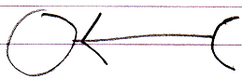 | 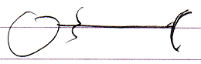 | 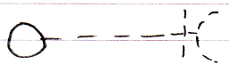
Protected Required  Object Get | Friend Required  Object Get | Public Required  Class Set
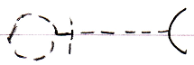 | 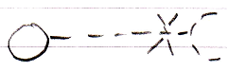 | 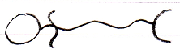
Public Required  Use As Class | Private Required  Class Set | Friend Required  Value Set
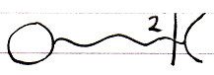 |  | 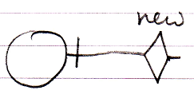
Public Required  Clone (2) Get | Public Required New | (as opposed to)  Public New
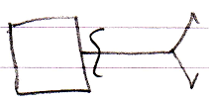 | 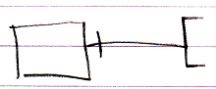 | 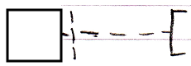
Friend Required  Execute | Public Required  Object Get | Public Required  Use As Class
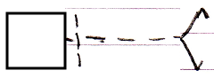
Public Required
Use As Class

(might be a better notation, since it is more likely to be used for plain command calls)

